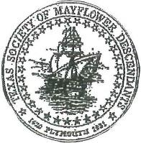

Applicant Name: ________________________________________________________________

Street Address: _________________________________________________________________

City: _________________________________ State: Texas Zip Code: ____________________

Phone: _____________________________ Email: ____________________________________

If you are a junior Member, please list your Texas Junior Number ________________________

Parent(s) Texas Society Membership Number(s) (if applicable) __________________________

Grandparent(s) Texas Society Membership Number(s) (if applicable) _____________________

**You will not be considered without this number, as this scholarship is just available to Mayflower descendants in our Texas society. If you need help finding this, email cbamben@hotmail.com**

Name of Parent(s) ______________________________________________________________

Address of Parent(s) _____________________________________________________________

Telephone: _____________________________ Email__________________________________

Name of High School: ____________________________________________________________

Expected date of Graduation: ____________________ Current GPA: ______________________

Do we have permission to publicize your award? Yes No

Signature: _____________________________________________________________________

If under 18, please have your parent sign for consent: __________________________________

Please provide a resume of your accomplishments limited to one page.

Please provide an essay 1000-1200 words on this topic.

* Write a letter to your ancestor telling him or her what you admired about them, and what virtues they had that you incorporated into your life. He or she also overcame some challenges. What challenge are you most proud of conquering? 1,000 -1200 words